Table of FEA SRM Service Domains and Service Types (see CRM.pdf)
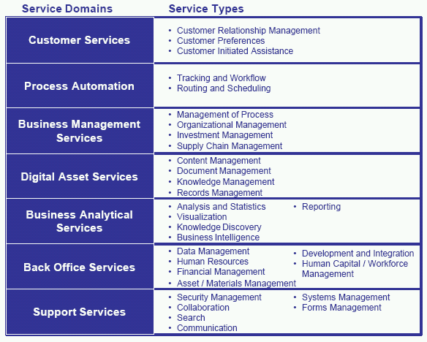

PICK JUST ONE SERVICE TYPE for any portion of your system. For example,
BUSINESS ANALYTICAL SERVICES domain, Visualization:

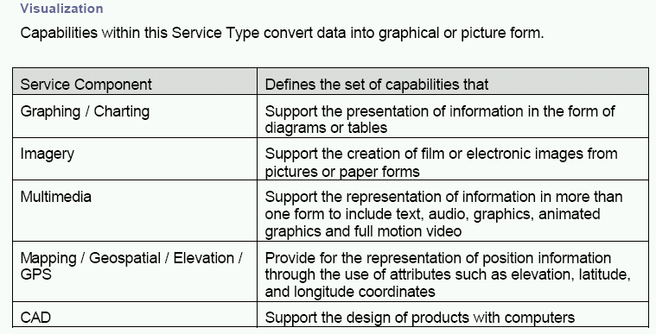

So, you would present a table that would show WHAT Graphing/Charting, Imagery, Multimedia, Mapping/Geospatial/Elevation/GPS, and CAD services (if any) were provided to users of that portion of your system. And if your chosen portion of your system doesn’t provide one or more of those services (for example, CAD or Graphing/Charting), then you would leave out those rows in your table.

